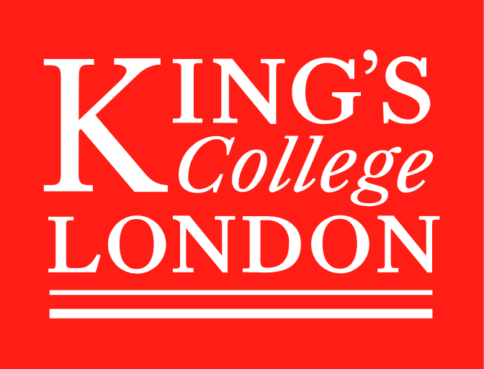
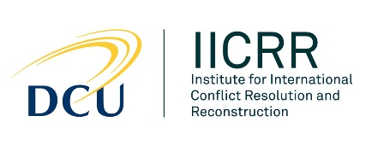

Armed Groups, Civilian Protection and United Nations Peacekeeping
Advanced Research Workshop
Wednesday 7th to Friday 9th November 2018
Venue: Dublin City University (Glasnevin campus), Ireland
Programme (Ver 3.0.2)
Wednesday 7th November 2018
Room Q220, Business School, DCU
13.30 Registration
14.00 Opening
14:15 Keynote speaker: Ralph Mamiya
International Peace Institute, and formerly UN Department of Peacekeeping Operation & Department of Field Support, New York
14.45 Coffee
15.00 Panel 1: Challenge of civilian protection
Peacekeeping reconsidered
Dr Philip Cunliffe, University of Kent and Editor-in-Chief, International Peacekeeping
How mandates have evolved and how PoC differs from protection in general
Prof Siobhán Wills, Transitional Justice Institute, Ulster University
Designing the PoC plan for UNIFIL
Lt Col Timothy O'Brien, UN Training School Ireland
Violence against civilians
Dr Sara Lindberg Bromley, Uppsala University
17.00 Close
18.00 Reception: 1838 Club, DCU Glasnevin Campus
19.00 Dinner: 1838 Club, DCU Glasnevin Campus

Thursday 8th November 2018
Room Q306, Business School, DCU

09.00 Panel 2: Review of actions so far
How the international community responds
Dr Klem Ryan
Case studies: DRC
Prof Ray Murphy, Irish Centre for Human Rights, National University of Ireland Galway
Mali: Protecting civilians in contexts of violent extremism and counter-terrorism
Dr Namie Di Razza, International Peace Institute
Case studies: South Sudan
Dr Hannah Dönges, Graduate Institute of International and Development Studies, Geneva
11.00 Coffee
11.30 Panel 3: Constraints and challenges
Coordination between humanitarian actors and CIMIC
Dr Hannah Dönges, Graduate Institute of International and Development Studies, Geneva
Unintended consequences of PoC
Dr Cedric de Coning
PoC camps as a means of protection (and how they arose)
Dr Walt Kilroy, Dublin City University
Relations with host states
Aditi Gorur, Stimson Center, Washington DC
13.30 Lunch
14.30 Audiovisual input – film (50 minutes plus discussion)
15.45 Coffee
16.00 Round table: Civilians as targets, and gender-based violence
Dr Sukanya Podder, King’s College London
Anna-Linn Persson, Folke Bernadotte Academy
Dr Sara Lindberg Bromley, Uppsala University
Dr Klem Ryan
Dr Namie Di Razza, International Peace Institute
Dr Walt Kilroy, Dublin City University
17.30 Close
17.45 Taxis from DCU to Skylon Hotel
19.30 Taxis from Skylon Hotel to city centre
20.00 Dinner: Market Bar (TBC) in city centre

Friday 9th November 2018
Room Q306, Business School, DCU

09.00 Break out – in small groups
(a) Publications
(b) Future research collaboration and funding
(c) Policy dialogue
10.15 Coffee
10.30 Panel 4: Ways to improve response
The role of elective approaches in training for PoC activities
Dr David Curran, Coventry University
The analysis of JMAC data to predict violence against civilians
Dr Allard Duursma, ETH Zurich
Innovation – In what ways can actors work together to advance civilian protection?
Aditi Gorur, Stimson Center, Washington DC
Tracing the effects of UN military protection operations in Africa (1999 to 2017)
Stian Kjeksrud, Norwegian Defence Research Establishment
12.30 Closing Remarks and summary of actions
Report back from working groups
Publication plans
Other actions
13.15 Close followed by lunch

Event Co-Directors
Dr Walt Kilroy
Institute for International Conflict Resolution and Reconstruction, Dublin City University
walt.kilroy@dcu.ie
Dr Sukanya Podder
King’s College London
sukanya.podder@kcl.ac.uk
Website: www.iicrr.ie/arw

Participants

Philip Cunliffe | University of Kent; Editor-in-Chief, International Peacekeeping
David Curran | Centre for Trust, Peace and Social Relations, Coventry University
Cedric de Coning | ACCORD and Norwegian Institute of International Affairs (NUPI)
Namie Di Razza | International Peace Institute
Hannah Dönges | Graduate Institute of International and Development Studies
Allard Duursma | ETH Zurich
Aditi Gorur | Stimson Center (USA)
Walt Kilroy | Institute for International Conflict Resolution and Reconstruction,  Dublin City University
Stian Kjeksrud | Norwegian Defence Research Establishment
Sara Lindberg Bromley | Uppsala University
Ralph Mamiya | Non-Resident Advisor, International Peace Institute  (formerly Team Leader, Protection of Civilians team, UN DPKO and Department of Field Support)  Co-editor of Protection of Civilians (OUP, 2016)
Ray Murphy | Irish Centre for Human Rights, National University of Ireland Galway
Timothy O'Brien (Lt Col) | School Commandant, United Nations Training School, Ireland
Anna-Linn Persson | Folke Bernadotte Academy
Sukanya Podder | King’s College London
Klem Ryan | Former coordinator, UN Panel of Experts on South Sudan
Siobhán Wills | Transitional Justice Institute, Ulster University

